Aim: First HTML Program

Program:

<html>

<head>

<title> **First Program** </title>

</head>

<body>

**Hello welcome to Web Technologies lab!**

**This is my first lab.**

</body>

</html>

Output:

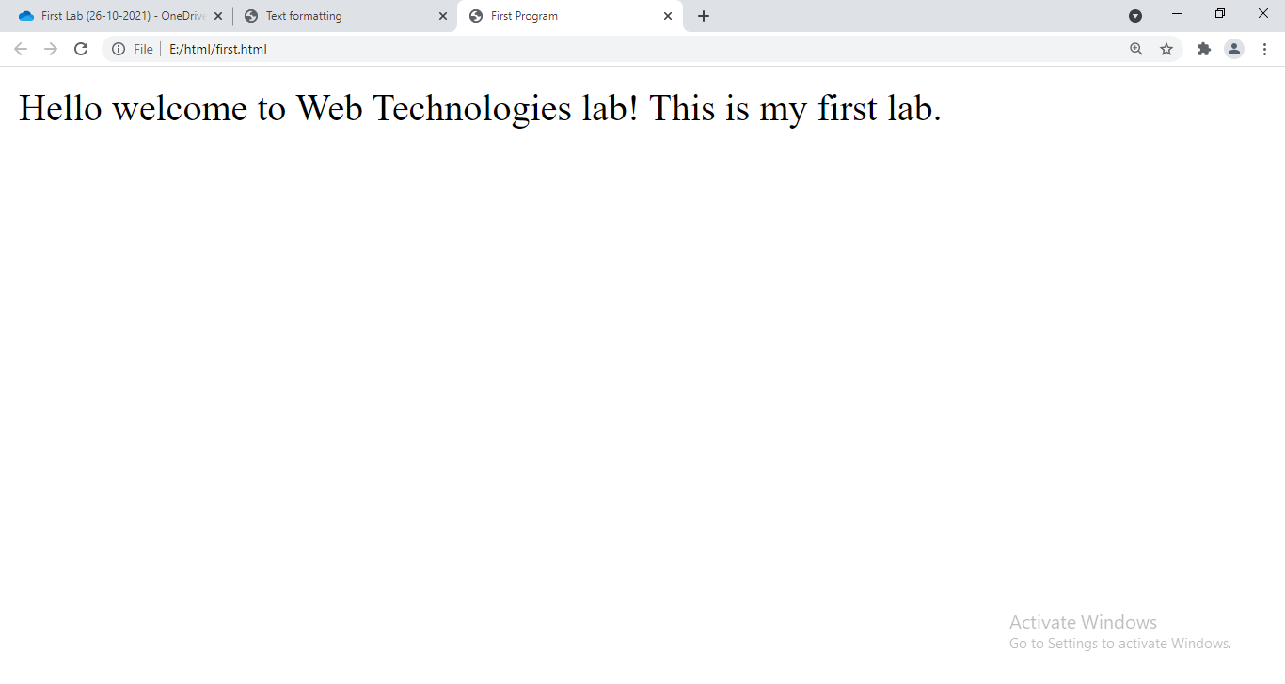

Aim: Background Color for the Text

Program:

<html>

<head>

<title> **First Program** </title>

</head>

<body bgcolor=**"yellow"**>

**Hello welcome to Web Technologies lab!**

**This is my first lab.**

</body>

</html>

Output:

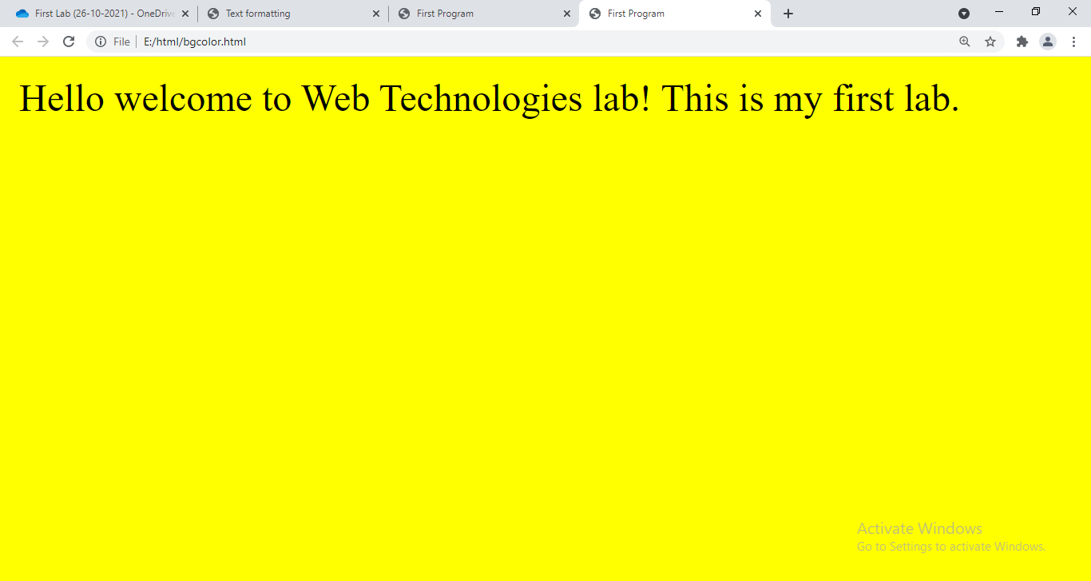

Aim: Text Color

Program:

<html>

<head>

<title> **First Program** </title>

</head>

<body bgcolor=**"black"** text=**"white"**>

**Hello welcome to Web Technologies lab!**

**This is my first lab.**

</body>

</html>

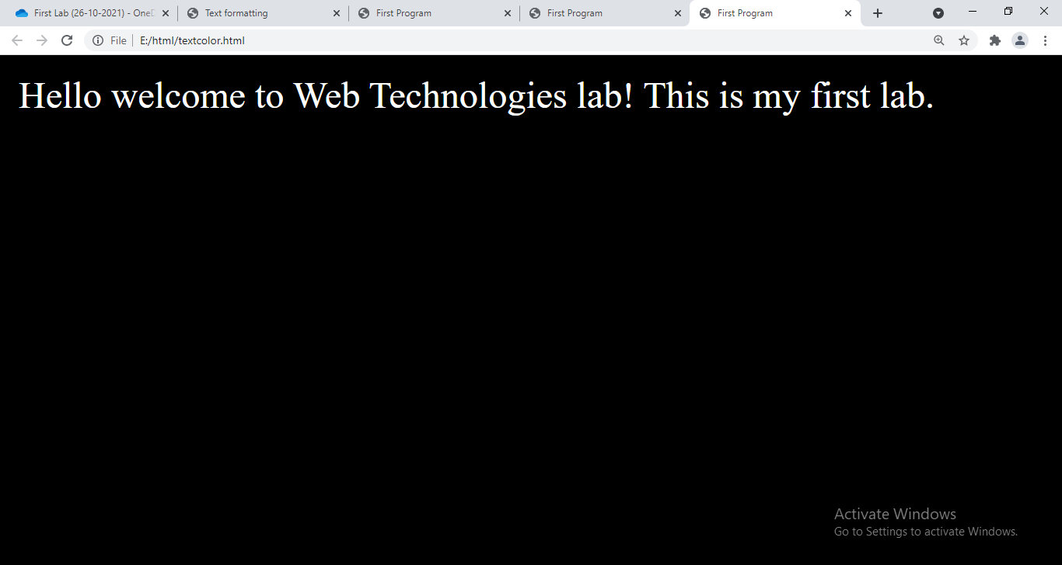

Aim: Using Break Tag

Program:

<html>

<head>

<title>**!!! My First WebPage !!!**</title>

</head>

<body bgcolor=**"black"** text=**"white"**>

**Hello welcome to Web Technologies lab!**<br>

**This is my first lab.**

</body>

</html>

Output:

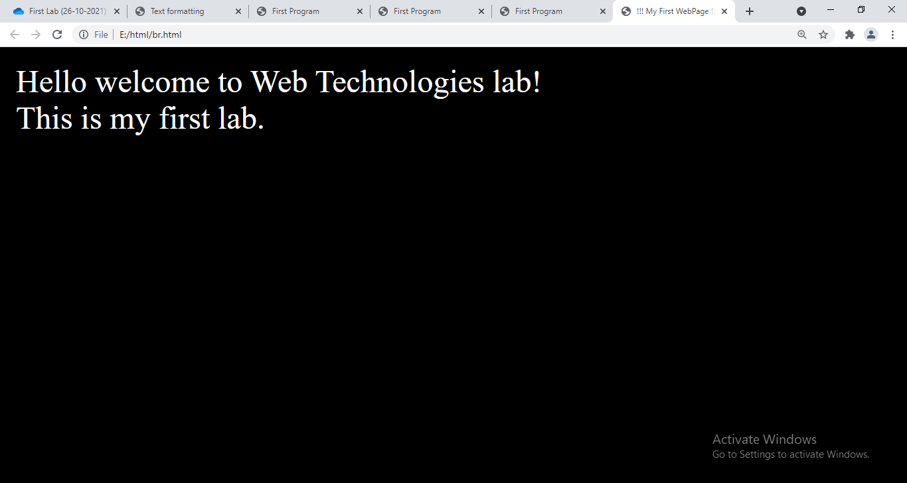

Aim: HTML Program to apply text formatting

Program:

<html>

<head>

<title>**Text formatting** </title>

</head>

<body>

<b> **This is bold text** </b><br>

<i> **This is a Italic Text** </i><br>

<u> **This is underlined text** </u><br>

<small> **This is small text** </small><br>

<big> **This is a Big text** </big><br>

<strike> **This is striked text** </strike><br>

**H**<sub>**2**</sub>**O** <br>

**X**<sup>**2**</sub><br>

</body>

</html>

Output:

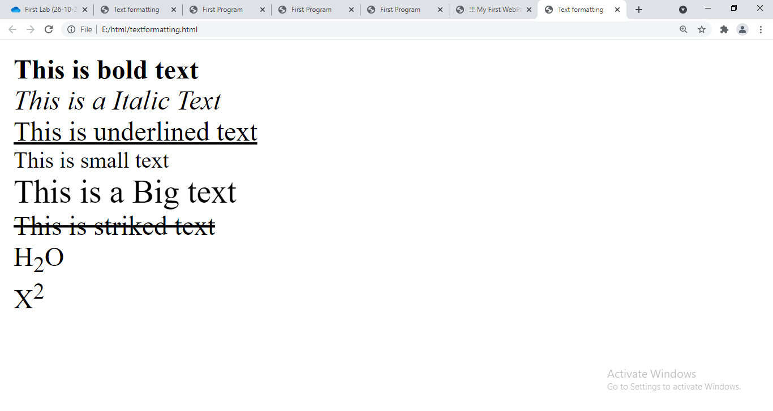

Aim: Using Font in Html document

Program:

<html>

<head>

<title>**Font**</title>

</head>

<body bgcolor=**"black"** text=**"white"**>

<b> **This is bold text** </b><br>

<i> **This is a Italic Text** </i><br>

<u> **This is underlined text** </u><br>

<font color=**"yellow"**>

<small> **This is small text** </small><br>

<big> **This is a Big text** </big><br>

<strike> **This is striked text** </strike><br>

</font>

**H**<sub>**2**</sub>**O** <br>

**X**<sup>**2**</sub><br>

<u><b><i>**III SEM CSE-B WT**</i></b></u><br>

<font size = 5 color = **"magenta"** >

**Hello this is a font text**

</font>

</body>

</html>

Output:

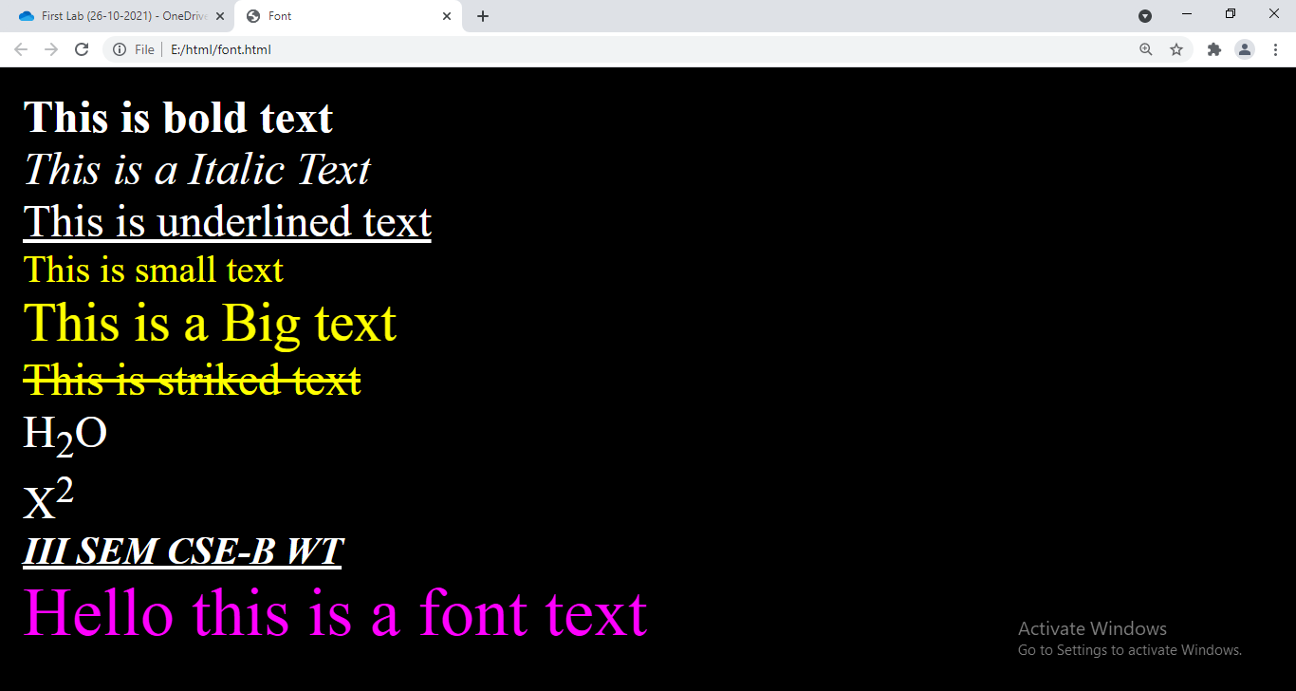

Aim: Using Heading Tag

Program:

<html>

<body text=**"orange"**>

<h1>**I am heading 1**</h1>

<h2>**I am heading 2**</h2>

<h3>**I am heading 3**</h3>

<h4>**I am heading 4**</h4>

<font color=**"purple"**>

<h5>**I am heading 5**</h5>

<h6>**I am heading 6**</h6>

<h1> **I am heading 1**</h1>

</font>

</body>

</html>

Output:

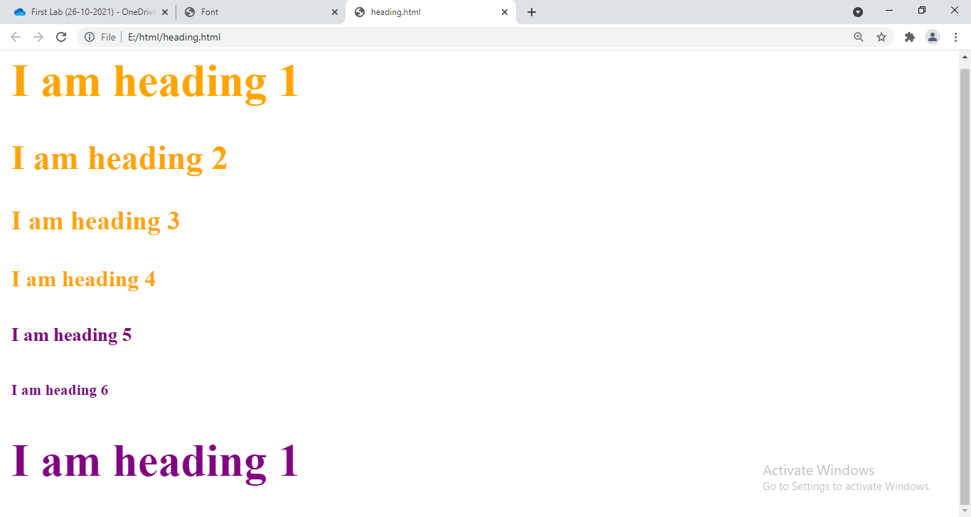

Aim: Using Align in Heading tag

Program:

<**html>**

**<body text="orange">**

**<h1 align="left">I am heading 1</h1>**

**<h2>I am heading 2</h2>**

**<h3>I am heading 3</h3>**

**<h4>I am heading 4</h4>**

**<font color="purple">**

**<h5 align="center">I am heading 5</h5>**

**<h6>I am heading 6</h6>**

**<h1 align="right"> I am heading 1</h1>**

**</font>**

**</body>**

**</html>**

Output:

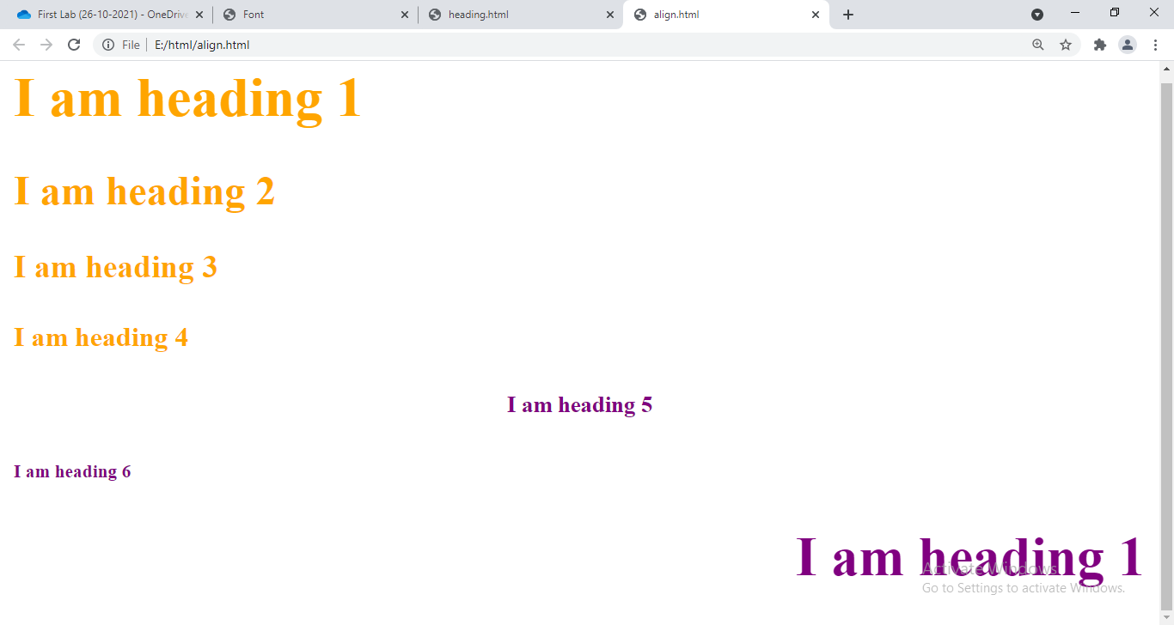

Aim: Using Marquee tag

Program:

<html>

<body>

<marquee> **This is marquee text** </marquee>

<marquee direction=**"right"**> **This is right moving text** </marquee>

</body>

</html>

**Output:**

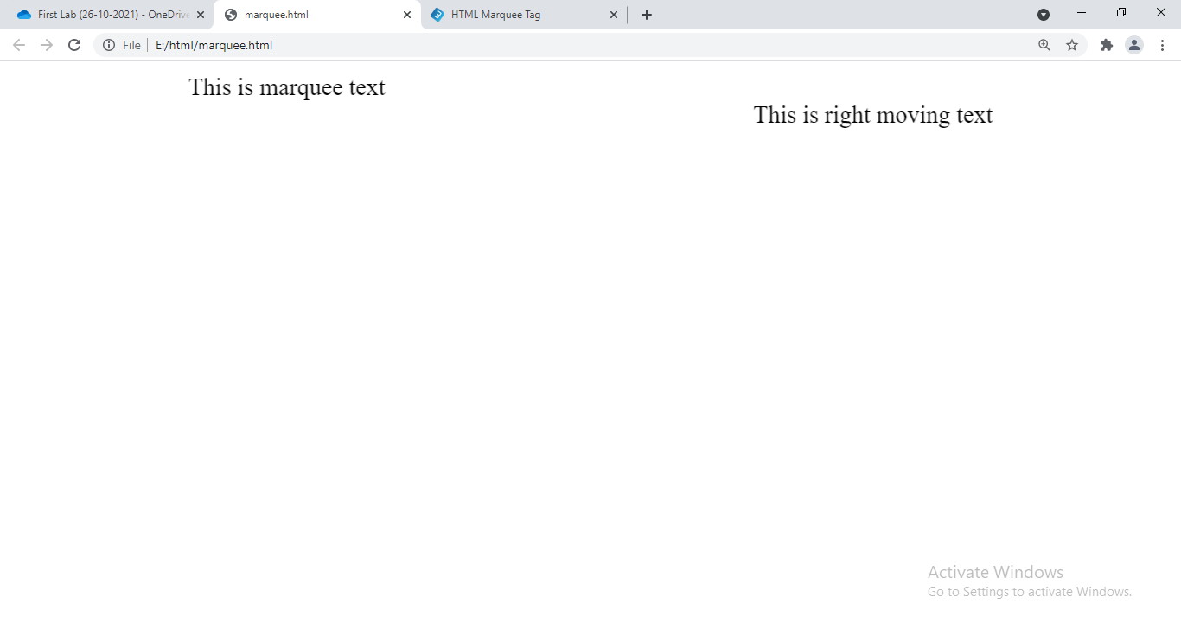

**Aim: Using Anchor Tag**

**Program:**

<html>

<body>

<a href=**"https://www.lbrce.ac.in"**>**Lbrce**</a><br>

<a href=**"https://www.youtube.com"**>**YouTube**</a><br>

<a href=**"https://www.google.com"**>**Google**</a>

</body>

</html>

**Output:**

